**FOR CLASS 8th**

**ROAD SAFETY**

**What is road safety?**

**Road** traffic **safety** refers to methods and measures for reducing the risk of a person using the **road** network being killed or seriously injured. The users of a **road** include pedestrians, cyclists, motorists, their passengers, and passengers of on-**road** public transport, mainly buses and trams.

**Speed limits**

On [motorways](http://en.wikipedia.org/wiki/Motorway) the maximum speed limit is 120 km/h for Motor Cars / LTV and for HTV / PSV it is 100 km/h. The minimum speed limit on motorway is 65 km/h. In urban residential areas on highways and on hilly areas, the speed limit is 50-70 km/h. On highways maximum Speed limit for Motor Cars / LTV is 100km/h and for HTV maximum Speed limit is 90km/h. Urban arterial roads generally have an 80 km/h limit and near School Colleges, Hospitals and mosque maximum Speed limit is 40km/h.

Remember over speeding is dangerous and may cause to a horrible accident.

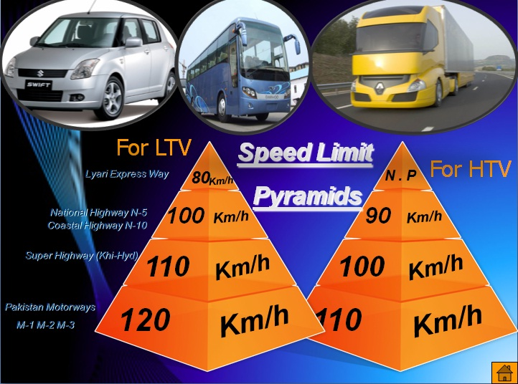

### Speed and accident risk

A higher speed increases the likelihood of an accident. Very strong relationships have been established between speed and accident risk: The general relationship holds for all speeds and all roads, but the rate of increase in accident risk varies with initial speed level and road type. Large speed differences at a road also increase the likelihood of an accident. In addition, drivers driving much faster than the average driver have a higher accident risk; it is not yet evident that this is also the case for the slower driver.

**Higher speeds: more accidents**

High speed reduces the possibility to respond in time when necessary. People need time to process information, to decide whether or not to react and, finally to execute a reaction. At high speed the distance covered in this period is longer. At high speeds the distance between starting to brake and a complete stand still is longer as well. The braking distance is proportional to the square of speed (*v2*). Therefore, the possibility to avoid a collision becomes smaller as speed increases.

*1 km/h increase in speed → 3% increase in accidents*

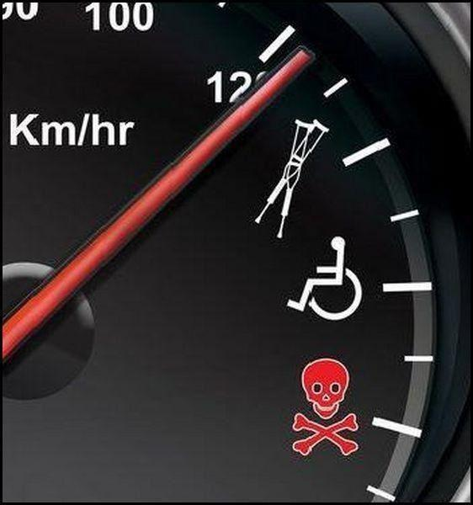

Truth of overspending

In practice the relationship is more complex. The exact relationship depends among many other things on speed level and road type.

*The higher the speed, the steeper the increase in accident risk*

The relationship between speed and accident risk is a power function: With increasing speed, the accident risk increases more as the absolute speed is higher.

**Always avoid overspending**

**Overtaking** Do not overtake unless you are sure it is safe and legal to do so. Overtake only on the right. You should:

* check your mirrors
* take time to judge the speeds correctly
* make sure that the lane you will be joining is sufficiently clear ahead and behind
* take a quick sideways glance into the blind spot area to verify the position of a vehicle that may have disappeared from your view in the mirror
* Remember that traffic may be coming up behind you very quickly. Check all your mirrors carefully. Look out for motorcyclists. When it is safe to do so, signal in plenty of time, then move out
* ensure you do not cut in on the vehicle you have overtaken
* be especially careful at night and in poor visibility when it is harder to judge speed and distance. Be sure you have sufficient distance to return to the same lane or line of traffic without endangering the vehicle being overtaken or any vehicle coming from the opposite direction
* Be sure no other vehicle is overtaking your vehicle by checking the road behind in your mirrors and blind spot

Do not overtake on the left or move to a lane on your left to overtake. In congested conditions, where adjacent lanes of traffic are moving at similar speeds, traffic in left-hand lanes may sometimes be moving faster than traffic to the right. In these conditions you may keep up with the traffic in your lane even if this means passing traffic in the lane to your right. Do not weave in and out of lanes to overtake.

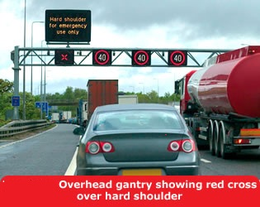

**Hard shoulder**  You **MUST NOT** use the hard shoulder for overtaking. In areas where an Active Traffic Management (ATM) Scheme is in force, the hard shoulder may be used as a running lane. You will know when you can use this because a speed limit sign will be shown above all open lanes, including the hard shoulder. A red cross or blank sign above the hard shoulder means that you **MUST NOT** drive on the hard shoulder except in an emergency or breakdown. In case of Emergency you can park your vehicle for a while on Hard Shoulder.

The basic, message and common sense is **“do not overtake unless you are sure you can”**.

Complete the maneuvers safely and without causing risk or inconvenience to another Road user.

* Signal your intention to overtake for long enough to give sufficient warning to all other road users.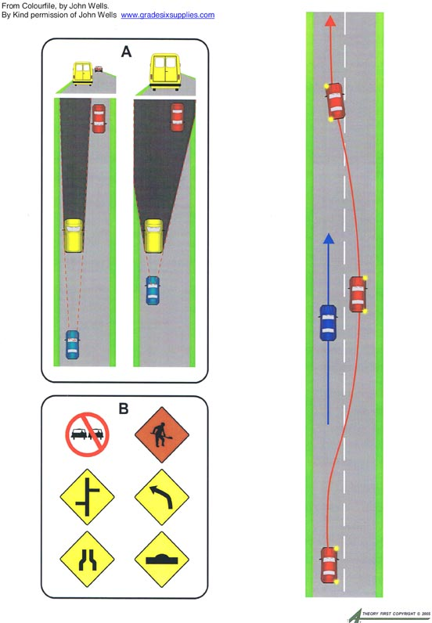

Right way of overtaking

**When you overtake, you must:**

Leave a safe gap between your vehicle and the vehicle you are overtaking. Do not return to the lane or line of traffic until you are far enough past the other vehicle to avoid a collision

**You must not overtake:**

* Where the road ahead is narrow
* On the approach to a children's or pedestrian crossing where another vehicle is stopping or has stopped to give way to pedestrians
* If there is a sign saying “No Overtaking”
* Approaching a crest, bend or dip in the road where there is not a clear view for a sufficient distance ahead to allow you to overtake safely
* On approaching an intersection or junction.

### *Being overtaken*

When driving a vehicle being overtaken by another vehicle, you must;

* keep to the left, if safe, to allow a reasonable space for the overtaking vehicle to pass or
* Keep within your lane and not increase your speed until the other vehicle has completely overtaken your vehicle and returned to the lane or line of traffic.

### *Procedure for over taking*

* If overtaking is necessary you must make sure it is safe to do so
* Use the right mirror properly and ensure that your right side and right lane is clear
* Do the rubber neck exercise for clearing the blind spot if necessary.
* Use the indicator in good time for lane changing.
* After changing the lane, switch off indicators.
* After overtaking make sure you are at a suitable distance from the vehicle, which you have over taken.
* Observe the left mirror and use the left indicator for lane changing from right to left



## Lights

The lighting system of a motor vehicle consists of [lighting](http://en.wikipedia.org/wiki/Light) and signalling devices mounted or integrated to various parts of a [motor vehicle](http://en.wikipedia.org/wiki/Motor_vehicle). These may include the front, sides, rear and, in some cases, the top of the vehicle. The purpose of this system is to provide [illumination](http://en.wikipedia.org/wiki/Lighting) for the driver and other road users. This enables safe vehicle operation after dark and increases the visibility of the vehicle. The lighting system allows other drivers and pedestrians to observe the vehicle's presence, position, size, direction of travel, and the driver's intentions regarding direction and speed of travel.

There are several lights in vehicles like head lights, indicators, brake light, reverse light, parking light, hazard lights, fog lights and room light etc. Each light convey different message and has different usability. Lights should be used in right time and on required circumstances according to need.

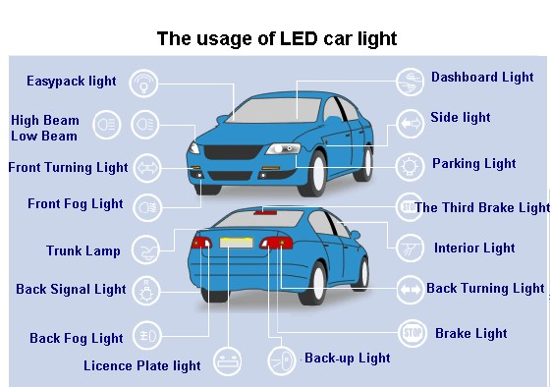

### *Hazard lights*

Hazard warning lights are a pair of intermittent flashing indicator lights that flash in unison to warn other drivers that the vehicle is a temporary obstruction. They are also called hazard flashers and hazard lights. They are usually activated by pressing a button on the dashboard that looks like a red triangle, as shown.

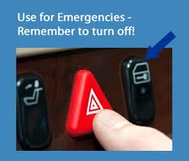

**When should you use hazard warning lights?**

They are to warn other road users that you are a temporary hazard. For example, if your vehicle is broken down on the side of the road, or you are changing a tyre and your cars being towed, you should use your hazard warning lights.

If you are being towed and you are using your hazard lights, you will need to use hand signals to indicate direction because the hazard lights override the indicators

**When shouldn't you use hazard warning lights?**

They shouldn't be used if you are driving in traffic. You should not use them to warn other drivers if you parked illegally (you shouldn't be parking illegally).