**FOR CLASS SEVEN**

**ROAD SAFETY**

**What is road safety?**

**Road** traffic **safety** refers to methods and measures for reducing the risk of a person using the **road** network being killed or seriously injured. The users of a **road** include pedestrians, cyclists, motorists, their passengers, and passengers of on-**road** public transport, mainly buses and trams.

**Cockpit Drill**

Before starting your journey, even before starting the engine, you should make a series of checks that will enhance both safety and comfort. The following checks are known as cockpit drill. For a driving test, when you first enter the car you are taking the test in, you must carry out the cockpit drill so that the test examiner can see that you are familiar with the routine.

***Doors***

Make sure that the boot, bonnet and all doors are closed properly.

***Seat Adjustment***

Adjust your seat so that you can comfortably reach all the controls. You should be able to fully depress the clutch and accelerator pedals without having to stretch.

***Steering Adjustment***

If the steering wheel is adjustable, adjust it so that your hands are resting comfortably a little lower than your shoulders.

***Mirror Adjustment***

Check your left, centre and right mirrors are correctly aligned, so that you can quickly see what's happening behind you with a glance, without having to move your head unnecessarily.

***Seat belt***

Put your seatbelt on making sure the belt isn't twisted. The belt should be strapped, adjust it so that it is 2-3cms higher than your shoulder, so that the belt gives a firm pressure over the top of your right shoulder, with no gap between the belt and the front of your shoulder.

***Hand Brake***

Make sure the handbrake is applied and that the gears lever is in neutral or parking position if driving an automatic vehicle. 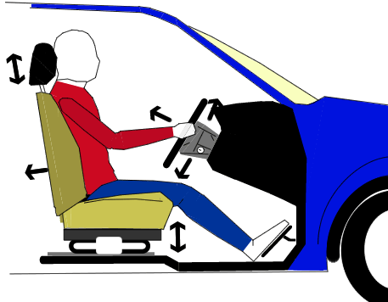

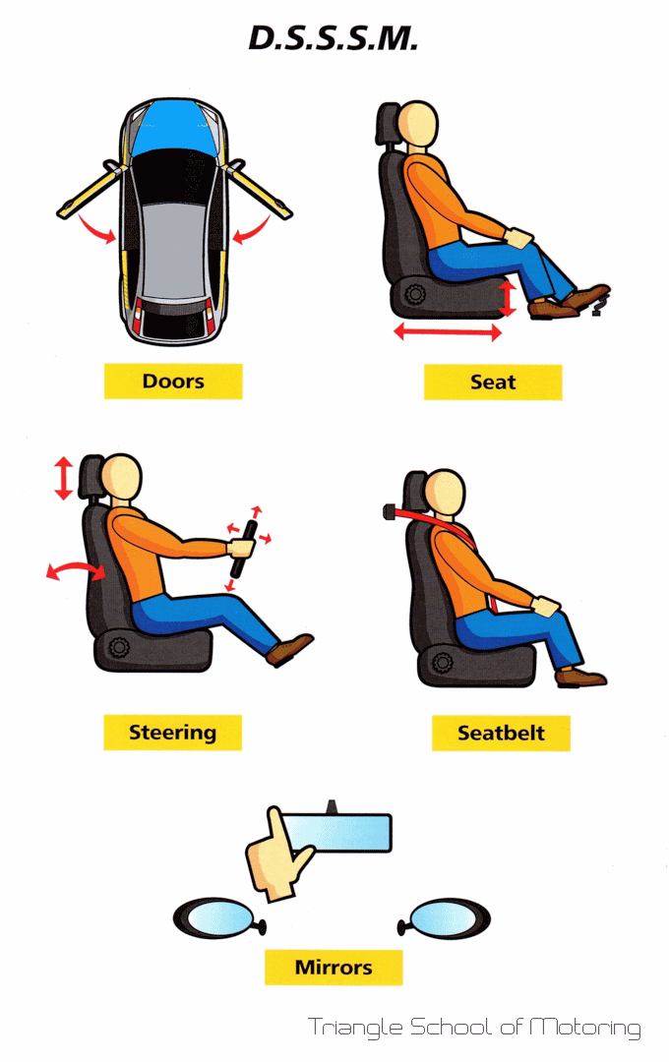

## Traffic Signs

Traffic signs are silent messengers. They are classified under the three categories:-

### *Mandatory Road Signs*

Mandatory signs are like an order. They are in circle shape. These signs are used to inform road users of certain laws and regulations to provide safety and free flow of traffic. These include all signs which give notice of special obligations, prohibition or restrictions with which the road user must comply. Violation of these signs is a legal offence.



Do not turn left at the intersection

### *Warning/Regulatory Road Signs*

Warning signs are always in triangle shape. These signs are used to warn the road users of the existence of certain hazardous conditions either on or adjacent to the roadway.

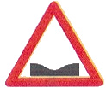

Road dip Narrow bridge ahead

### *Informatory Road Signs*

Informatory signs are usually in rectangle shape. These signs are used to guide road users along routes, inform them about destination and distance, identify points of historical interest and other information etc.



Shows route to airport

#### (a) Motorway Road Signs

[Motorway signs](http://www.roadsign.pk/motorway-road-sign) are type of informative signs in green colour. Their purpose is to provide information, help and direction. For example Lahore in right direction and Multan in left direction.

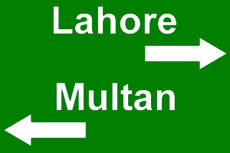

#### (b) National Highway Road Sign

[National Highway signs](http://www.roadsign.pk/highway-road-sign) are type of informative signs in blue colour. Their purpose is to provide information. For example Murree is 20 KMs away.

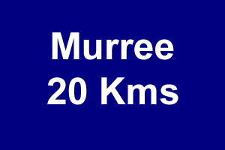

#### (c) Construction Road Signs

[Construction signs](http://www.roadsign.pk/construction-road-sign) are type of informative signs in orange color. For example work in progress. The purpose is to reduce the speed and be careful.

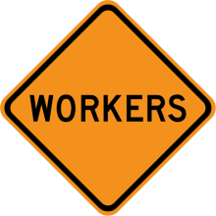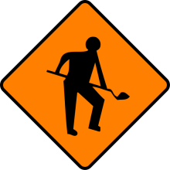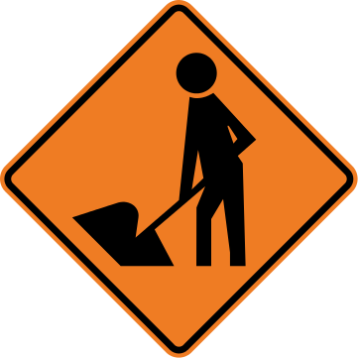

#### (d) Hazardous Signs

[Hazardous signs](http://www.roadsign.pk/hazardous-material-sign) are type of informative signs which warn about explosive materials. Purpose is to tell or ask road users to maintain safe distance and be careful.

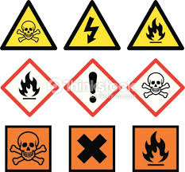

**General Guidelines**

* A driver should never bring a vehicle on road that is not in satisfactory condition.
* Use of safety helmet is must while driving a motorcycle, scooter or moped and for the pillion rider also.
* No one should ever drive without wearing seat belt.
* Proper functioning of lights and indicators are mandatory to drive on road.
* Appropriate light or manual signals must be used before starting, stopping, slowing down, turning or changing lanes, clearly, correctly and well in time.
* Change lane only when necessary and do not change more than one lane at a time.
* Slow moving and heavy transport vehicle must remain in the extreme left lane.
* Overtaking is allowed only from the right side.
* While joining the main road, one must give way to the traffic and join only when way is clear.
* Give way to the traffic in the round about.
* Emergency vehicles must be given way overriding all other rules and priorities.
* No vehicle is allowed to reverse on a main road or within a school zone in any case.
* Instructions of the traffic police officer in uniform must be obeyed even if they are in contravention of any rule.

ACTIVITY

**Answer with True and False**

1. Keep the slow moving vehicle in the extreme left lane. **(T/F)**
2. Overtake only from the right side. **(T/F)**
3. Remain in the middle lane while driving heavy transport vehicle. **(T/F)**
4. Obey the signals of the traffic police officer in uniform even if they are in contravention of any rule **(T/F)**
5. While turning right give way to the traffic approaching from the opposite direction. **(T/F)**
6. Give way to the traffic in the round about. **(T/F)**
7. No one is allowed to reverse a vehicle on a main road. **(T/F)**
8. While driving a motorcycle, scooter or moped and the pillion rider must wear a safety helmet. **(T/F)**
9. A vehicle can be carefully reversed in school zone if required. **(T/F)**
10. If necessary more than one lane can be changed at once. **(T/F)**