FOR CLASS SIX

ROAD SAFETY

What is Road Safety?

Road traffic safety refers to methods and measures for reducing the risk of a person using the road network being killed or seriously injured. The users of a road include pedestrians, cyclists, motorists, their passengers, and passengers of on-road public transport, mainly buses and trams.

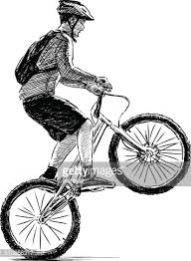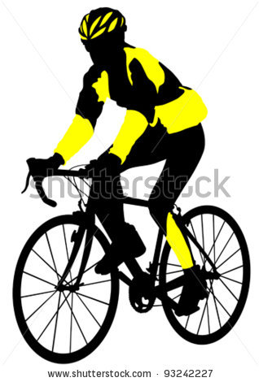

Cycling: In early age children love to ride bikes. By the time they start school; most children are capable of riding a bike of their own, but not far and not on busy roads. Some of the children at the age of 9-12, try to do one-wheeling, which is most dangerous, which can cause head injury and it is often said as death trap. Children must wear cycle helmet before riding and always run their bikes on the extreme left side of the street. Never try to ride on the main road.
2. What is POWER?
P Petrol / Gas
O Oil / Lubricants / Engine Oil, Brake Oil, Clutch Oil, Auto Transmission Fluid
W Water / Coolant Level etc.
E Electrical articles (Battery, Lights, Sound System, Indicators etc.)
R Rubber Parts (Tyres / Wipers etc.)

Signal by Police
Stopping & Beckoning Signals

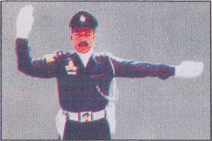 | 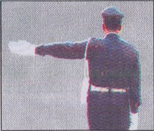 | 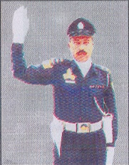
Traffic approaching from both front and behind. | Traffic approaching from behind. | Traffic approaching from the front
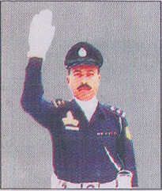 | 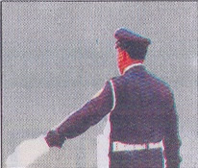 | 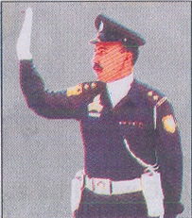
Beckoning on traffic from the front | Beckoning on traffic from behind | Beckoning on traffic from the side

Motorway Signals & Signs

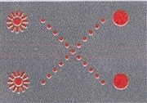 | 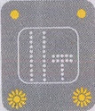 | 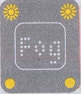
Don’t proceed further in this lane | Lane ahead closed | Reduced visibility ahead
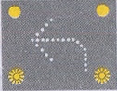 | 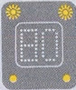 | 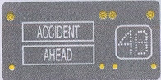
Leave motorway at next exit | Temporary maximum speed limit | Information message & temporary speed limit

Route Markers

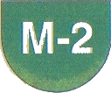 | 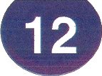 | 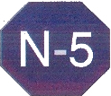 | 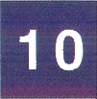
Motorway | Provincial Road | National Highway | District Road

Mandatory Traffic Signals

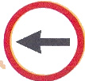 | 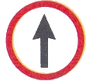 | 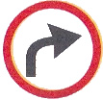 | 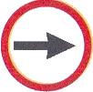
Turn to the left | Go straight ahead | Turn to the right | Turn to the right
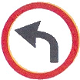 | 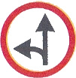 | 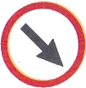 | 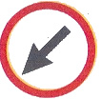
Turn to the left | Go straight or left | Keep to the right | Keep to the left
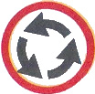 | 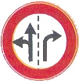 | 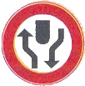 | 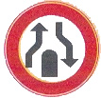
Compulsory roundabout | Lane control sign | Dual Carriageway ahead | Dual carriageway end

Regulatory/Warning Signs

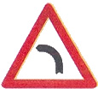 | 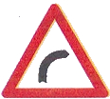 | 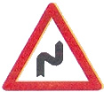 | 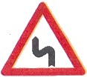
Left bend | Right bend | Double bend to the right | Double bend to the left
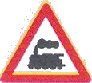 | 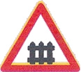 | 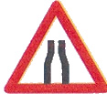 | 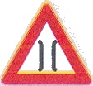
Level crossing (without gate) | Level crossing (with gate) | Carriageway narrow | Narrow bridge
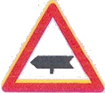 | 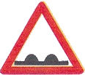 | 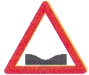 | 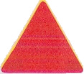
Major cross road | Un-even road | Road dips | Advance danger

General Guidelines:

- Use of safety helmet is must while driving a motorcycle, scooter or moped and the pillion rider. It saves from head injuries while an accident.
- No one should ever drive without wearing seat belt. It saves 75% from injuries while an accident and sudden break.
- Children below the age of 12 years must sit on the rear seat of the car.
- Proper functioning of lights and indicators of a vehicle are mandatory to drive on road. Appropriate light or manual signals must be used before starting, stopping, slowing down, turning or changing lanes, clearly, correctly and well in time.
- Using of mobile phone while driving is highly dangerous.
- Change lane only when it is necessary and do not change more than one lane at a time.
- Overtaking is allowed only from the right side.
- While joining the main road one must give way to the traffic and join only when road is clear. Give way to the traffic in the round about.
- Emergency vehicles and Ambulance must be given way overriding all other rules and priorities.

- No vehicle is allowed to reverse on a main road or within a school zone in any case.

- Instructions of the traffic police officer in uniform must be obeyed even if they are in contravention of any rule.

- No horn in front of hospital.

Answer with True and False

- Keep the slow moving vehicle in the extreme left lane. (T/F)
- Overtake only from the right side. (T/F)
- Remain in the middle lane while driving heavy transport vehicle. (T/F)
- Obey the signals of the traffic police officer in uniform even if they are in contravention of any rule (T/F)
- While turning right give way to the traffic approaching from the opposite direction. (T/F)
- Give way to the traffic in the round about. (T/F)
- No one is allowed to reverse a vehicle on a main road. (T/F)
- While driving a motorcycle, scooter or moped and the pillion rider wear a safety helmet. (T/F)
- A vehicle can be carefully reversed in school zone if required. (T/F)
- If necessary more than one lane can be changed at once. (T/F)

Which of the following signs implies narrow bridge ahead. Please “X” it?

- b.

c.

Match the caption with respective sign:

Dual carriageway end

Dual Carriageway ahead

Go straight or left

Lane control sign

