For Class-11/12

ROAD SAFETY

What is road safety?
Road traffic safety refers to methods and measures for reducing the risk of a person using the road network being killed or seriously injured. The users of a road include pedestrians, cyclists, motorists, their passengers, and passengers of on-road public transport, mainly buses and trams.

USE OF HELMET
Motorcycle helmets are basically aimed at absorbing the impact of collision to the brain in case of an accident. With this in mind, among the first things that one should be looking for is the material of the helmet. Lightweight, tough and crack resistant fibbers and grades of plastic have made it into the helmet manufacturing processes in a big way. Impact resistance can be gauged from the shape and size of the helmets. One ought to educate oneself to ensure that the money spent is worth it.
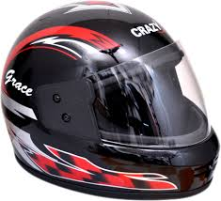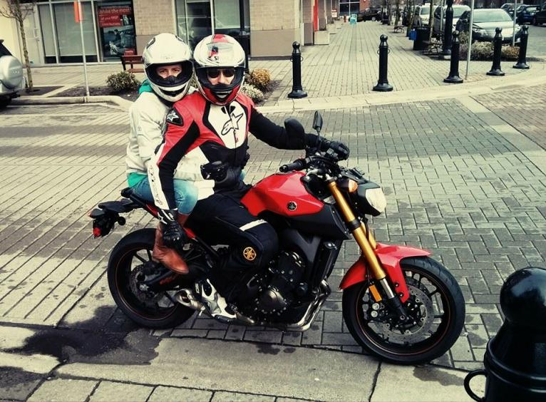
Helmets and Motorcycle Safety
According to the 2014 statistics of the Road Traffic Injury Research and Prevention Centre, which collects data of road accidents from five public and private sector hospitals of the Karachi city only, which shows 24,360 accidents and 30,274 injuries were reported last year. Over 1,000 people died in traffic accidents in Karachi only (the number could be much higher considering the fact that the data is based on information received from hospitals that receive brought-dead cases).
Each year more than 2,200 people are killed and more than 55,000 are injured in motorcycle crashes in Pakistan(the number could be much higher considering the fact).
If these individuals had been wearing helmets, many of these deaths and disabling injuries would not have happened. Why? Because a helmet is the motorcyclist�s most ffective piece of safety equipment.
ONE WHEELING
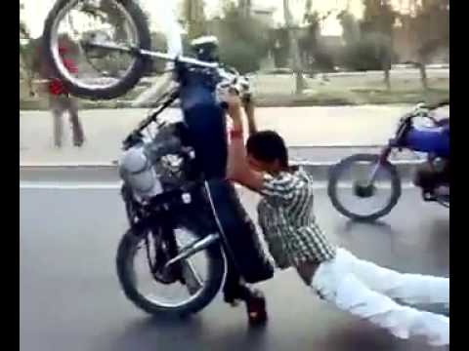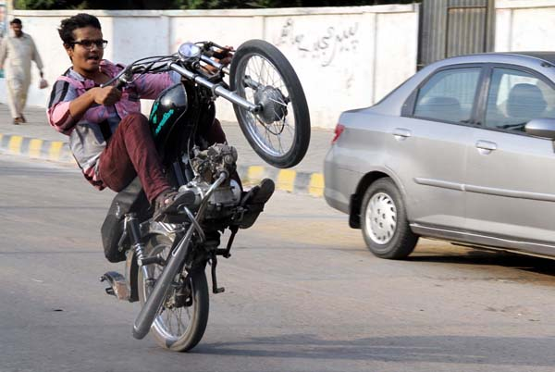
“One-wheeling is basically riding a motorbike, using a single wheel, which is dangerous,” and leads towards death trap.
Pakistan is the only country where young bike riders without wearing helmets resort to one-wheeling, often carry out dangerous stunts like lying flat, standing on motorbikes and driving with backs facing the handle.

Lights
The lighting system of a motor vehicle consists of lighting and signaling devices mounted or integrated to various parts of a motor vehicle. These may include the front, sides, rear and, in some cases, the top of the vehicle. The purpose of this system is to provide illumination for the driver and other road users. This enables safe vehicle operation after dark and increases the visibility of the vehicle. The lighting system allows other drivers and pedestrians to observe the vehicle's presence, position, size, direction of travel, and the driver's intentions regarding direction and speed of travel.
There are several lights in vehicles like head lights, indicators, brake light, reverse light, parking light, hazard lights, fog lights and room light etc. Each light convey different message and has different usability. Lights should be used in right time and on required circumstances according to need.

Hazard lights
Hazard warning lights are a pair of intermittent flashing indicator lights that flash in unison to warn other drivers that the vehicle is a temporary obstruction. They are also called hazard flashers and hazard lights. They are usually activated by pressing a button on the dashboard that looks like a red triangle, as shown.

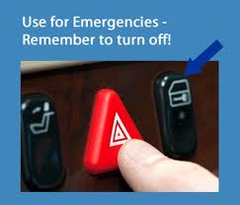

HOW WELL CAN YOU SEE AHEAD?
Many users are confused about when to use of low beam and high beam headlights.
Think about this: low beams let you see about 200 feet ahead. It can take about 200 feet to stop when you drive at 30 mph. That is almost half a city block in length. If you cannot see 200 feet ahead, you may not be driving safely at 30 mph. By the time you see an object in your path, it may be too late to stop without hitting it.
Headlights on “upper” or “high” beam let you see about 350-400 feet ahead. 400 feet is your approximately stopping distance when driving at 50-55 mph. That is about the length of a city block.
In other words, high beams let you see twice as far as low beams.

WHEN TO USE HIGH BEAM HEADLIGHTS
In any situation when you cannot see well enough ahead, you should start by slowing down. Remember the basic speed law and the two-second rule. When you cannot see well enough, you must increase your following distance which means more seconds. If there are no oncoming vehicles, turn on your high beam headlights.
In general, you should always use high beams outside cities and in rural areas, as long as there are no other vehicles around. Dim your lights when there are oncoming vehicles, or when you are approaching another vehicle from behind.
During poor visibility it is particularly important to use high beams on unfamiliar roads, on dark city streets, in construction areas, or where there may be people or bicyclists along the side of the road. Remember to adjust you speed and not overdrive your headlights.
You must also dim your headlights in all situations when there is a risk of blinding other drivers with your high beams.

Driver Negligence/Distraction
Driving is a full time job and most of the accidents (90%) due to drivers’ negligence or distraction. There has been much attention about driver distraction due to the use of mobile phones in vehicles, but increasingly research is also revealing the dangers of other forms of driver multi-tasking, and its out driver distraction, other road users, riders, cyclists, and even pedestrians can also be distract contribution to road accidents.
Driver is distracted when they pay attention to a second activity while driving. People cannot always safely multi-task in this way, especially if the second activity is time consuming or complex.
The second activity puts extra demands on the driver, which may reduce his or her driving standard. For example, it may cause the driver to become less observant or to make worse decisions about how to control the vehicle safely. This lower standard of driving means that a driver is more likely to fail to anticipate hazards, and means accidents can occur due to the distraction.
In theory, there are as many potential causes of distraction as there are things to which drivers could pay attention. In reality, however, drivers tend to priorities information so that they pay the most attention to information or activities needed for driving.
Distraction can be either driver initiated (where the driver starts carrying out a distracting activity) or non-driver initiated (the unpredictable actions of something or someone else).
Objects, events, or activities both inside and outside the vehicle can cause distraction. In-vehicle distractions can be caused by technology, or by other sources inside the vehicle such as passengers. External distractions may be when a driver concentrates on unimportant events or objects, or when another person does something unusual.
Please remember! Driving is a full time job and any type of distraction by the driver may cause to an accident. Following some road signs which can save your travelling, if remembered.
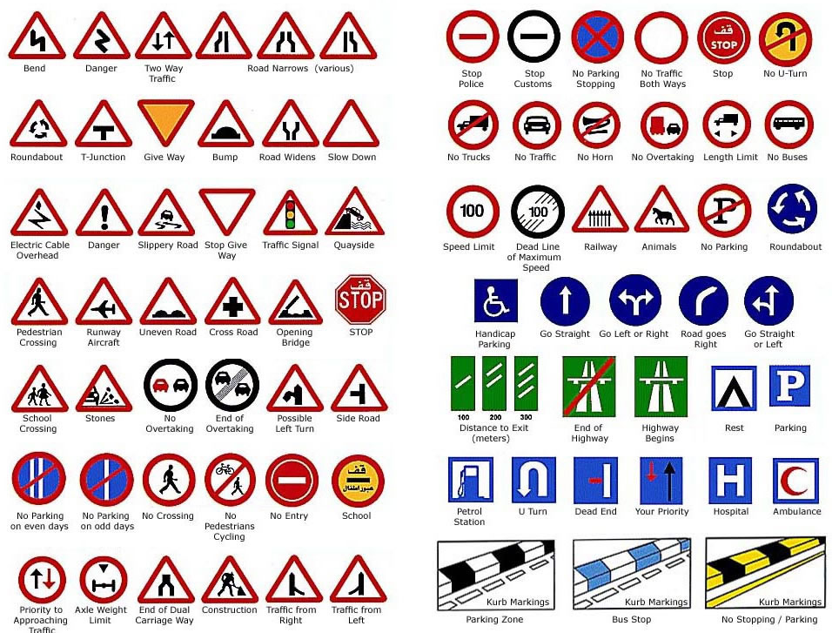
Road Safety saves your life.
*****************

