**FOR CLASS-10**

**ROAD SAFETY**

**What is road safety.**

**Road** traffic **safety** refers to methods and measures for reducing the risk of a person using the **road** network being killed or seriously injured. The users of a **road** include pedestrians, cyclists, motorists, their passengers, and passengers of on-**road** public transport, mainly buses and trams.

**SEAT BELT:**

A **seat belt**, also known as a **safety belt**, is a vehicle safety device designed to secure the occupant of a [vehicle](https://en.wikipedia.org/wiki/Vehicle) against harmful movement that may result during a [collision](https://en.wikipedia.org/wiki/Collision) or a sudden stop. A seat belt functions to reduce the likelihood of [death](https://en.wikipedia.org/wiki/Death) or serious [injury](https://en.wikipedia.org/wiki/Injury) in a [traffic collision](https://en.wikipedia.org/wiki/Traffic_collision) by reducing the force of [secondary impacts](https://en.wikipedia.org/wiki/Second_Impact_(safety)) with interior strike hazards, by keeping occupants positioned correctly for maximum effectiveness of the [airbag](https://en.wikipedia.org/wiki/Airbag) (if equipped) and by preventing occupants being ejected from the vehicle in a crash or if the vehicle rolls over.

While driving, the driver and passengers are travelling at the same speed as the car. If the car suddenly stops or crashes, the driver and passengers continue at the same speed the car was going before it stopped. A seatbelt applies an opposite force to the driver and passengers to prevent them from falling out or making contact with the interior of the car. Motor vehicle crashes are a leading cause of death among those aged 1-54. More than 2.2 million adult drivers and passengers were treated in emergency departments in US only in 2012. Seat belt uses is the most effective way to save lives and reduce injuries in road crashes.

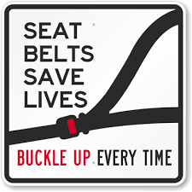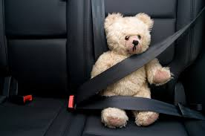

How big is the problem of crash related - injuries and death?

Motor vehicle crashes are a major public health problem.

* Non-fatal crash injuries resulted in more than $50 billion in lifetime medical and work loss costs in 2012.
* Motor vehicle crashes are the leading cause of death among teens.
* Young adults (18-24) have the highest crash-related injury rates of all adults.

What is the impact of seat belt use?

* Seat belts reduce serious crash-related injuries and deaths by about half.
* Air bags provide added protection but are not a substitute for seat belts. Air bags plus seat belts provide the greatest protection for adults.
* Seat belt saves more than 85% from injuries during road crashes or applying sudden breaks.

Who is least likely to wear a seat belt?

* Of the teens (aged 13-20 years) that died in crashes in 2012, approximately 55% of them were not wearing a seat belt at the time of the crash.
* Adults age 18-34 are less likely to wear seat belts than adults age 35 or older.
* Men are 10% less likely to wear seat belts than women.

# Mobile phones and driving safety

[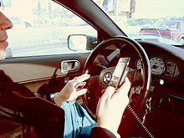](https://en.wikipedia.org/wiki/File:Hand_held_phone_in_car.JPG)

[**Mobile phone**](https://en.wikipedia.org/wiki/Mobile_phone) use while driving is common, but widely considered dangerous due to [distracted driving](https://en.wikipedia.org/wiki/Distracted_driving). Due to the number of accidents that are related to cell phone use while driving, as per law the use of cell phone directly or through [hands free](https://en.wikipedia.org/wiki/Handsfree) device is illegal and leads towards accident.

**Mobile phones**

* Driving is a task that requires all of your attention in order to be safe. There is a lot of research showing that mobile phones distract people from other tasks.
* ***Using ANY mobile phone when driving is dangerous***
* Using a mobile phone, or using hands free device means that the driver’s attention is distracted from the road.

**Can I use a mobile phone with the phone in my hand while driving?**

No. Driving with a mobile phone in the driver's hand is illegal. This includes, but is not limited to, making and receiving calls and any other function of the phone. You can be fined if your mobile phone is in your hand for any reason while you are driving.

**Can I use a mobile phone that is in my hand while stopped at traffic lights or in a queue of congested traffic?**

No. If you are stopped in traffic it is illegal for the driver to use a mobile phone that is held in his or her hand.

**Can I stop on the side of the road to use my mobile phone?**

Yes so long as you park legally.

**The facts**

* Studies show that drivers using a hands-free, text or handheld mobile phone are slower at recognizing and reacting to hazards and a split-second lapse in concentration could result in a crash.

**The law**

* It's illegal to use a handheld mobile when driving.
* This includes using your mobile phone to follow a map, read a text or check social media. This applies even if you’re stopped at traffic lights or queuing in traffic.
* You can only use a handheld phone if you are safely parked or need to call motorway police helpline “130” or any emergency No. e.g. 15 or 119 etc in an emergency.
* If you’re caught using a handheld phone while driving, you’ll get penalty of fine of Rs.300 or more.
* You may use a hands-free phone while driving but you can still be prosecuted if you’re not in proper control of your vehicle. The penalties are same as being caught using a handheld phone.

**What does ‘park legally’ mean?**

To stop and stay in an area where there is no prohibition on stopping or parking. It is recommended that you secure the vehicle by applying parking brakes; put the automatic transmission into ‘park’ and turn off the ignition.

**What is the best road safety advice for the use of mobile phones while driving?**

The link between driver distraction and increased crash risk has been demonstrated by a number of studies. The Motorway Police wants drivers to recognize that any action that distracts from the driving task is a risk to their safety (as well as everyone else’s). Drivers should choose not to engage in potentially dangerous activities while driving. Too many drivers in Pakistan are being distracted while on the road by things like mobile phones, iPods and other hand-held devices.

## Traffic Signs

Traffic signs are silent messengers. They are classified under the three categories:-

### *Mandatory Road Signs*

Mandatory signs are like an order. They are in circle shape. These signs are used to inform road users of certain laws and regulations to provide safety and free flow of traffic. These include all signs which give notice of special obligations, prohibition or restrictions with which the road user must comply. Violation of these signs is a legal offence.



Do not turn left at the intersection

### *Warning Road Signs*

Warning signs are always in triangle shape. These signs are used to warn the road users of the existence of certain hazardous conditions either on or adjacent to the roadway.



Narrow bridge ahead

### *Informatory Road Signs*

Informatory signs are usually in rectangle shape. These signs are used to guide road users along routes, inform them about destination and distance, identify points of historical interest and other information etc.



Shows route to airport

#### Motorway Road Signs

[Motorway signs](http://www.roadsign.pk/motorway-road-sign) are type of informative signs in green colour. Their purpose is to provide information, help and direction. For example Lahore in right direction and Multan in left direction.

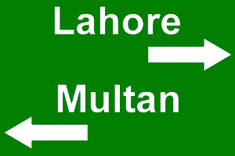

#### National Highway Road Sign

[National Highway signs](http://www.roadsign.pk/highway-road-sign) are type of informative signs in blue colour. Their purpose is to provide information. For example Murree is 20 KMs away.

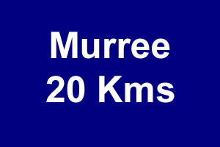

#### Construction Road Signs

[Construction signs](http://www.roadsign.pk/construction-road-sign) are type of informative signs in orange color. For example work in progress. The purpose is to reduce the speed and be careful.

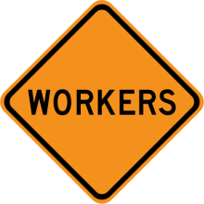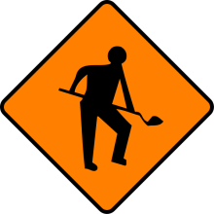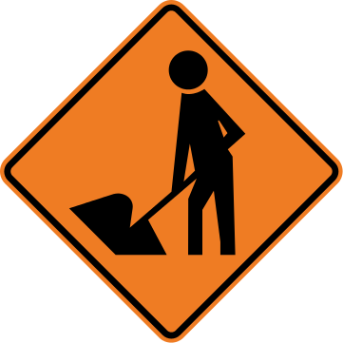

#### Hazardous Signs

[Hazardous signs](http://www.roadsign.pk/hazardous-material-sign) are type of informative signs which warn about explosive materials. Purpose is to tell or ask road users to maintain safe distance and be careful.



